**E-bank money account transaction API**

**1. URL：**

**Local: http://localhost:8880/swagger-ui/#/**

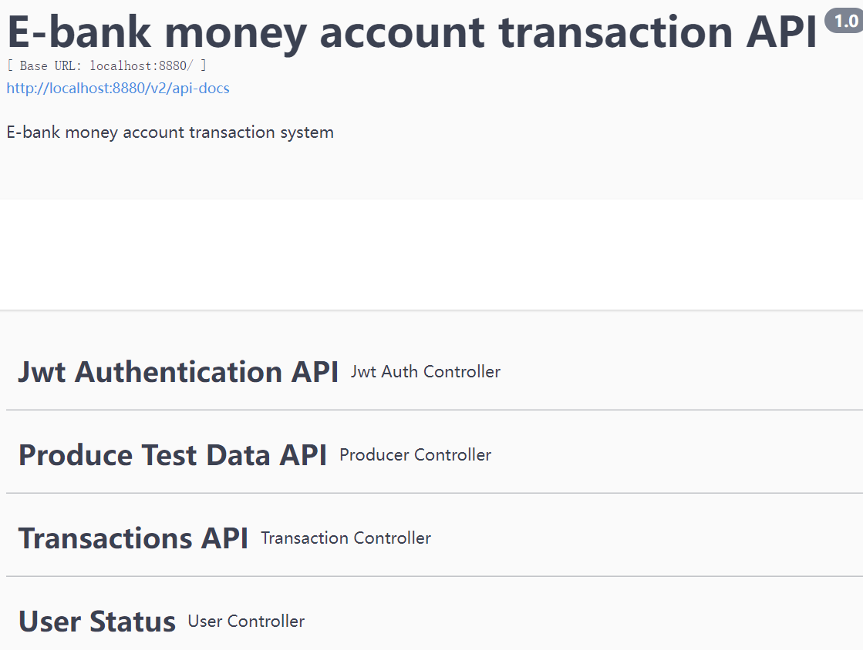

**2. Get the token first:**

* **Click the first controller api “Jwt Authtication API”, go to api “/jwtauth/token” in “POST”。**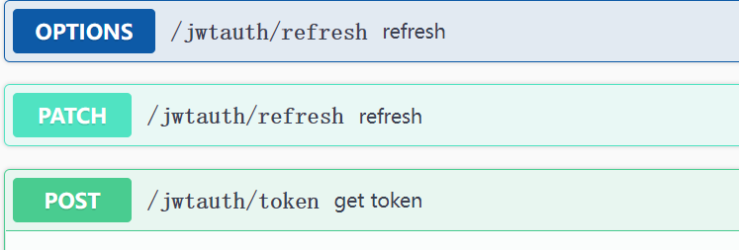
* **Click the button “ Try it out”**

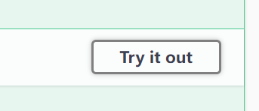

* **Case 1:In the field “map”, input the right username and password:**

**{**

**"username": "Greyson",**

**"password": "123456"**

**}**

**Click the “Execute”, will get response:**

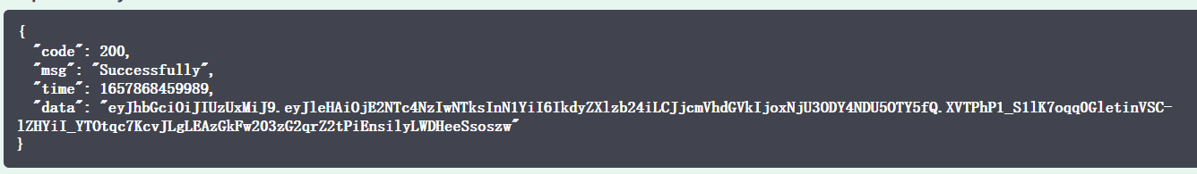

**Case 2: the password or name is wrong, will get:**

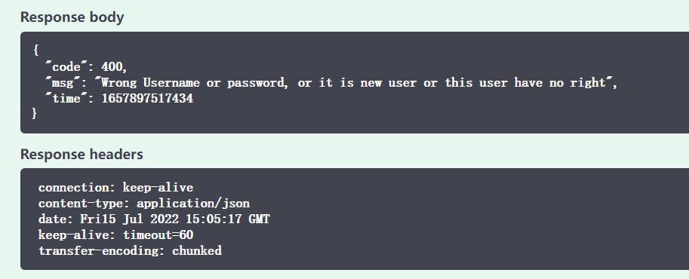

* **After get the right token, click the button:** 

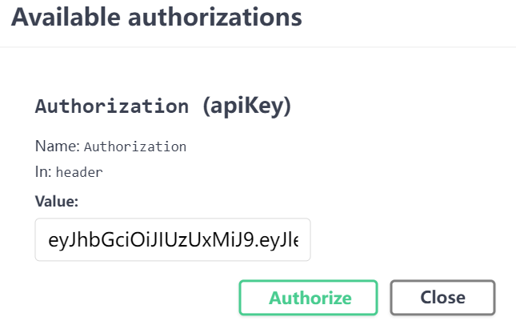

* **Then “Authorize” it, then close the dialog.**

**3. Produce Test Data API:**

**Case 1: Didn’t get the token, click the button “Try it out”:**

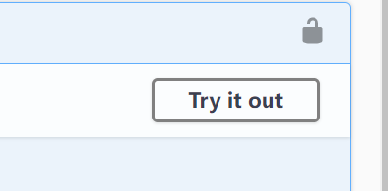

**No parameters need input 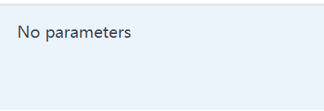, click “Execute”, will get the response:**

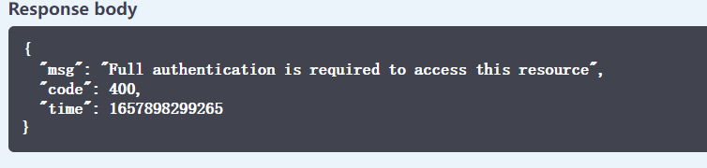

**Case Two: the user already login, click the button “Execute”:**

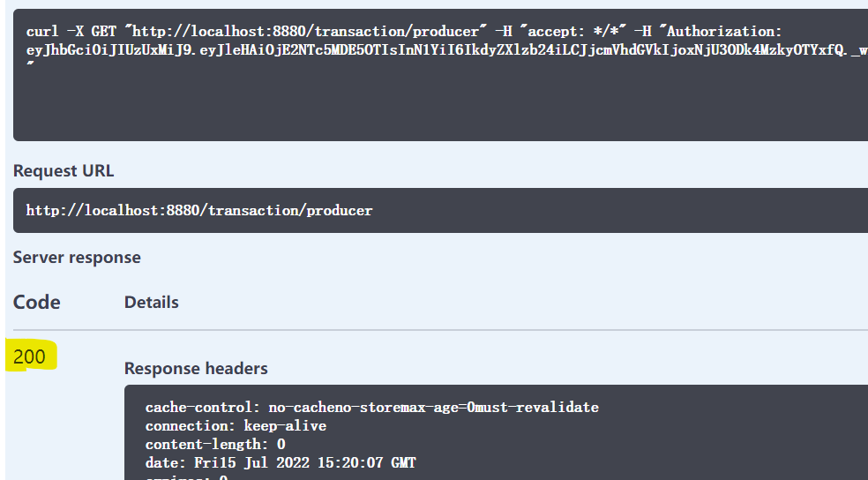

**And we can check the log will see:**

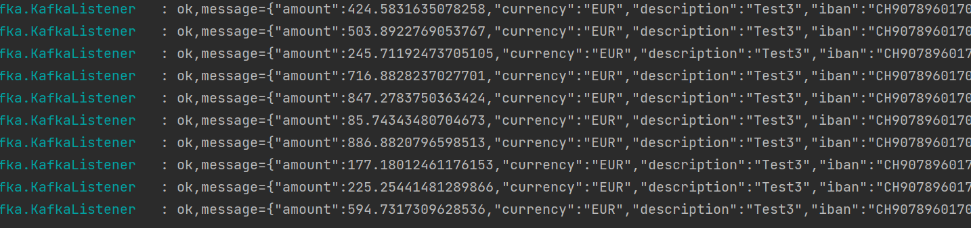

**4. Transactions API:**

**Case 1: Didn’t get the token, click the button “Try it out”:**



**No parameters need input , click “Execute”, will get the response:**



**Case 2: the user already login, click the button “Execute”:**

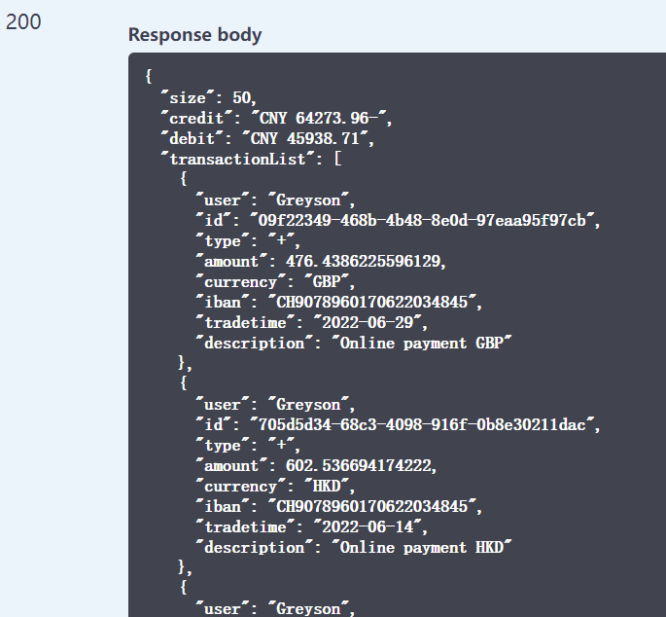

**5. User status:**

**Case 1: Didn’t get the token, click the button “Try it out”:**



**No parameters need input , click “Execute”, will get the response:**



**Case 2: the user already login, click the button “Execute”:**

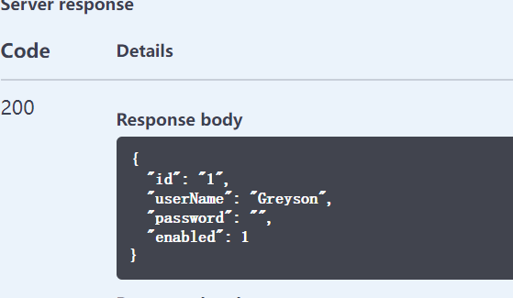

**6. Api contract test in postman:**

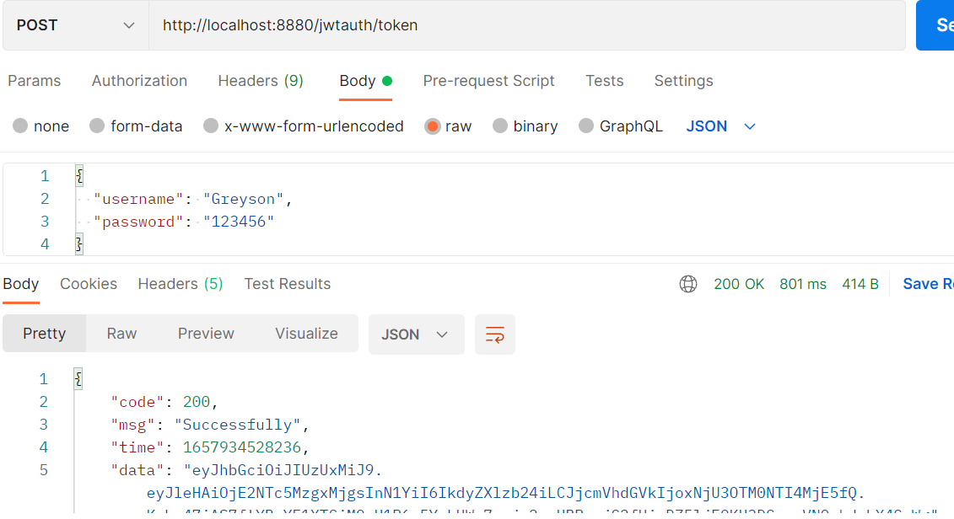

**Producer:**

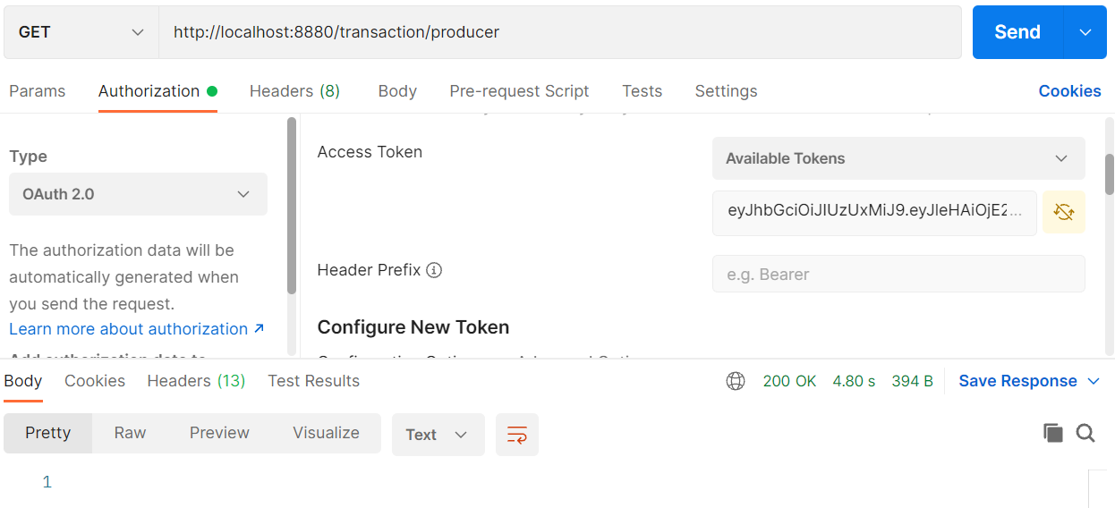



**Transactions:**

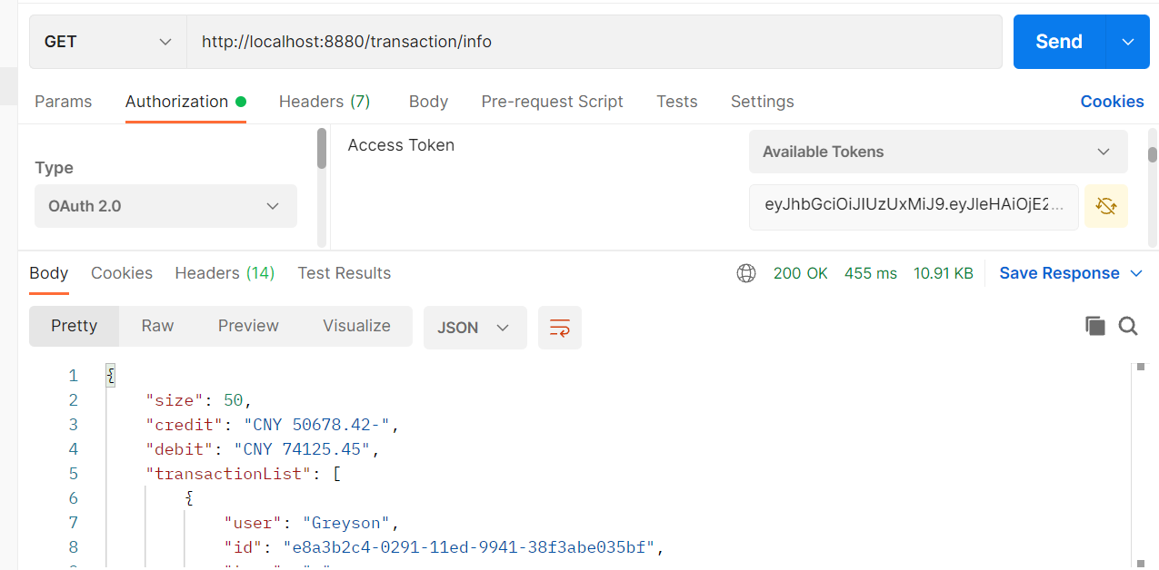

**And User status:**

